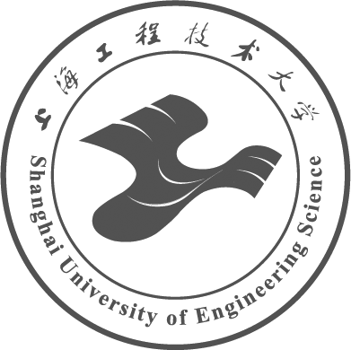 | Graduate Department
 | Shanghai University of Engineering Science
 | No.333, Longteng Road, Shanghai, 201620,P.R.China
 | Tel:+86-21-67791224
 | Web: http://ge.sues.edu.cn

CERTIFICATE OF DIPLOMA

This is to certify that XXX（学生姓名，如Li Sisi）, XXX（性别，如male/ female）, born on XXX（出生年月日，如Nov. 5, 1990）, was enrolled in Shanghai University of Engineering Science in XXX（入学年月，如September, 2016）, majoring in XXX（学科或专业名称，如Mechanical Design and Theory）, having passed all the courses and thesis, graduated in XXX（毕业年月，如March, 2019）.
President: XXX（校长姓名，如Yu Tao）
Certificate No: XXX（毕业证书编号）
Date of Issue: XXX（毕业证书签发日期，如Mar. 31, 2019）

Graduate Department
Shanghai University of Engineering Science
XXX（申请英文学历证明日期，如Dec. 3, 2021）

Graduate Department
Shanghai University of Engineering Science
No.333, Longteng Road, Shanghai, 201620,P.R.China
Tel:+86-21-67791224
Web: http://ge.sues.edu.cn

CERTIFICATE OF MASTER DEGREE

This is to certify that XXX（学生姓名，如Li Sisi）, XXX（性别，如male/ female）, born on XXX（出生年月日，如Nov. 5, 1990）, was enrolled in Shanghai University of Engineering Science in XXX（入学年月，如September, 2016）, majoring in XXX（学科或专业名称，如Mechanical Design and Theory）, having passed all the required courses and thesis, in accordance with the Academic Degree Regulations of the People’s Republic of China, was awarded the Master Degree of XXX（学科门类，如Engineering）.
President: XXX（校长姓名，如Yu Tao）
Chairman of Degree Evaluation Committee: XXX（学位评定委员会主席姓名，如Yu Tao）
Certificate No: XXX（学位证书编号）
Date of Issue: XXX（学位证书签发日期，如Apr. 24, 2019）

Graduate Department
Shanghai University of Engineering Science
XXX（申请英文学历证明日期，如Dec. 3, 2021）

